http://www.access-board.gov/caac/mock-up.htm
Courtroom mock-ups play a key role in the planning and design of courthouses. They provide a “test-run” of courtroom designs so that problems can be identified and refinements made before construction. Details of courtroom features, including the elevation of raised spaces and sight lines, can be tested and verified, before designs are finalized. Basic construction materials, such as plywood and drywall, are typically used.
On November 14th, members of the Board and the Courthouse Access Advisory Committee toured a full-scale courtroom mock-up prepared by the General Services Administration (GSA) with support from the Administrative Office of the U.S. Courts (AOC). The mock-up represented a standard Federal district courtroom design that incorporated access recommendations adopted by the Committee. It provided an opportunity to validate and improve the Committee’s design recommendations. This mock-up was reconfigured to represent a special proceedings courtroom, which Committee members reviewed the following day.
The Board and Committee are thankful to GSA and AOC staff for preparing these mock-ups, including Robert Andrukonis, GSA’s representative on the Committee, Brian Gifford of GSA, Gate Lew, AOC’s representative on the Committee, and Kathleen Desmond and Ray Heath of AOC.
The mock-up design featured:  - access by ramps to all raised spaces, including the judge's bench, witness stand, jury box, and clerk stations  - ample wheelchair maneuvering and turning space within all raised areas  - traditional vertical separation for the bench and other raised areas |  | 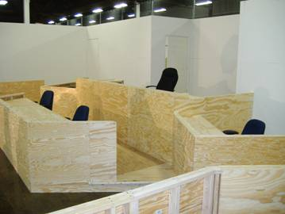
Ramp to Jury Box and Witness Stand
Both the witness stand and the jury box are raised, with one ramp providing access to both locations.
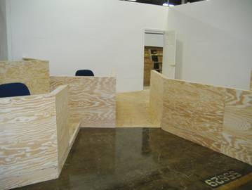 |  | 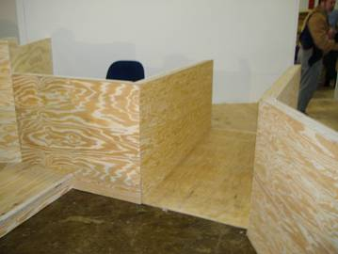
Jury Box
The first tier of the jury box, which is raised one level above the court floor, provides wheelchair space in proximity to the ramp. The wheelchair space is 5 feet deep, which facilitates entry from the side. Available turning space also allows easier wheelchair maneuvering into and out of the jury box.
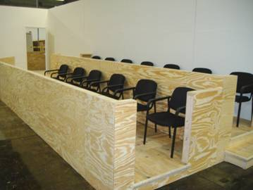 |  | 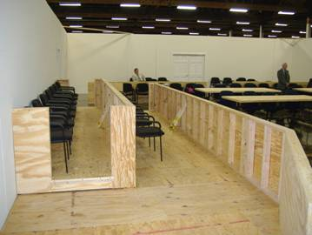
Witness Stand
The witness stand is also sized and configured to provide easy wheelchair maneuvering to and from the ramp.
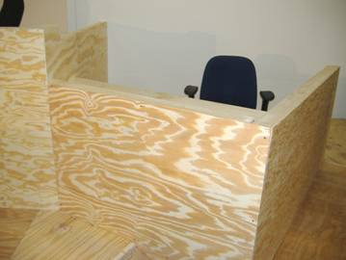 |  | 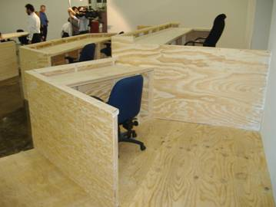
Ramp Access from Jury Box  A ramp immediately outside the courtroom provides a continuous accessible route from the jury box to other spaces, such as jury deliberation suites. |  | 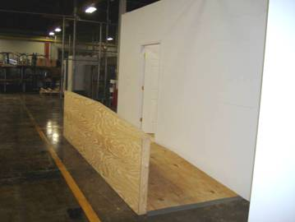
Judge's Bench
The judge's bench is raised 18 inches and is served by a ramp located outside the courtroom in the secured corridor. Locating ramps outside the courtroom, as recommended by the Committee, allows judges with disabilities to enter and exit courtrooms at the level at which they preside, affording them equivalent decorum and security.
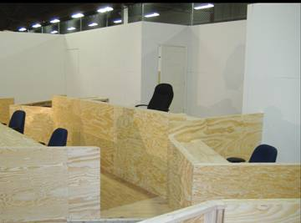 |  | 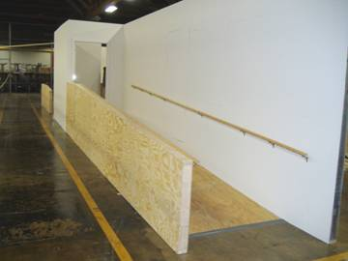
Sight Lines
Designs are often refined as a result of mock-ups. In this mock-up, it was determined that the line of sight from the bench to the witness stand would be enhanced by a lower side rail. This modification was made during the review to verify that the resulting sightline was sufficient.
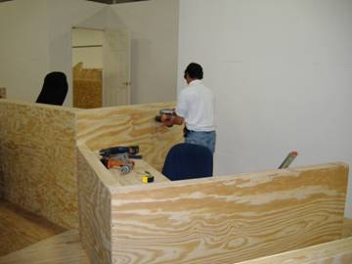 |  | 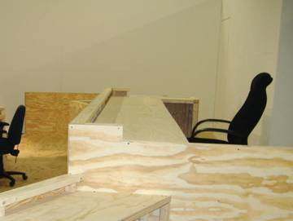
Clerk Stations
A ramp provides access to a clerk station located next to the bench. It also provides an accessible route attorneys can use to approach the bench for sidebars. The clerk station, like the witness stand, provides sufficient wheelchair maneuvering space.
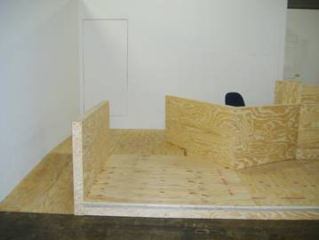 |  | 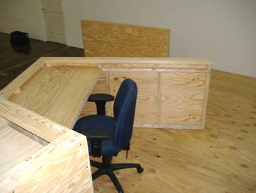
Clerk and Court Reporter Stations
The same ramp also serves additional clerk and court reporter stations located in front of the bench.
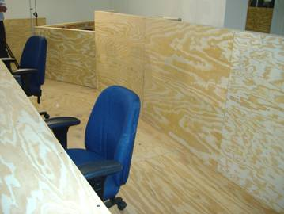 |  | 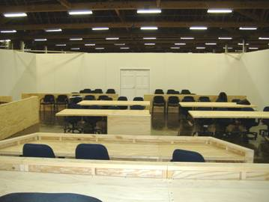
Spectator Seating  The mock-up included the spectator area and a rail with no gate, as recommended by the Committee. |  | Lectern  The Committee's recommendations also address lecterns that are adjustable and that provide knee and toe clearances for wheelchair access.
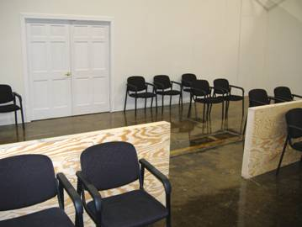 |  | 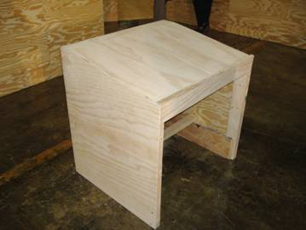
Design Modification  The design plans were revised based on the mock-up review. |  | Feedback  Board and Committee members discussed comments and feedback on the mock-up, which were very favorable.
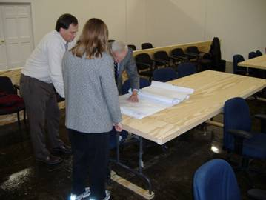 |  | 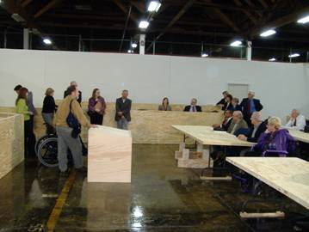

Courthouse Access Advisory Committee Courtroom Mock-Up

